October Newsletter 2017
“IN THE KNOW” at SNAPPY TOWN
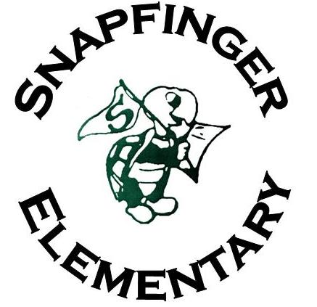
LOOKING AHEAD

Nov. 4: Red Ribbon Week ends
Nov. 5: Daylight Savings Time ends
Nov. 7: Election Day-Please remember to vote-
Nov. 10: Veterans Day
Nov. 13-17: Parent Engagement Week
Nov. 15: Progress Reports issued
Nov. 15: Thanksgiving Luncheon–PreK-2nd
Nov. 16: Thanksgiving Luncheon-3rd -5th
Nov. 16: Crossing Guard Appreciation Day
Nov. 16: Parent/Teacher Conference
Nov. 20-24: Thanksgiving Holiday-NO SCHOOL
Nov. 23: HAPPY THANKSGIVING!
Nov. 29: 7:00-800am “Welcome Wednesday” -M.E.N.T. to be involved: (Men Engaging Nurturing and Teaching). Positive Male Role Models will greet our students as they arrive at school. Volunteers are needed.

SNAPFINGER PARENT RESOURCES
Principal Johnny Potter
Assistant Principals Camille Blakely & Yvonne Browder
Counselors Angelia Garnett & Clifford Johnson Parent Liaison Lottie Rivers
Region 5 Family Engagement Facilitator-Demetria Purkett-Brown
Snappy Town Number: 678-874-1856

1365 Snapfinger Road Decatur, GA 30032
http://www.snapfingeres.dekalb.k12.ga.us/

IMPORTANT DATES
Oct. 3: Grandparents Luncheon – 10:30am-12:45pm
Oct. 5 & 6: – FALL BREAK – NO SCHOOL
Oct.9: COLUMBUS DAY – NO SCHOOL
Oct 10: Lunch/Learn –“We’re Here For You” Title I Parent Workshop - 11:30am – 1:30 pm, Media Center – Come out to get information on all the programs and services available for you and your child at Snapfinger. Bring your own lunch or share mine. You don’t want to miss this one!
Oct. 18: Progress Reports issued.
Oct. 20: Snapfinger celebrates International Walk to School Day – All walkers today will be recognized.
Oct. 24: Parent- Teacher Conferences – 3:30-5:30pm
Oct. 24: Study Skills: Now or Later Parent Workshop – 5:00-6:30pm – Refreshments will be served.
Oct. 25: “Welcome Wednesday” (M.E.N.T. to be involved: (Men Engaging Nurturing and Teaching)–7:00-7:45am Positive Male Role Models will greet our students as they arrive at school. Volunteers are needed.
Oct. 30-Nov. 3: Red Ribbon Week
Oct. 31: Halloween – Keep safe!
Remember: Students are NOT allowed to wear costumes or masks to school!
.

INFINITE CAMPUS – Don’t forget to sign up. Keep up with your child’s grades and assignments on a daily basis.

